**MANDATORY HANDS-ON**

**Exercise 1: Configuring a Basic Spring Application**

**MainApp.java**

package com.library;  
  
import com.library.services.BookService;  
import org.springframework.context.ApplicationContext;  
import org.springframework.context.support.ClassPathXmlApplicationContext;  
  
public class MainApp {  
 public static void main(String[] args) {  
 ApplicationContext context =  
 new ClassPathXmlApplicationContext("applicationContext.xml");  
  
 BookService bookService = (BookService) context.getBean("bookService");  
 bookService.addBook("The Great Gatsby");  
 }  
}

**BookService.java**

public class BookService {  
  
 private BookRepository bookRepository;  
  
 public void setBookRepository(BookRepository bookRepository) {  
 this.bookRepository = bookRepository;  
 }  
  
 public void addBook(String bookName) {  
 System.*out*.println("Adding book: " + bookName);  
 bookRepository.saveBook(bookName);  
 }  
}

**BookRepository.java**

package com.library.repository;  
  
public class BookRepository {  
 public void saveBook(String bookName) {  
 System.*out*.println("Book '" + bookName + "' saved to the repository.");  
 }  
}

**pom.xml(Library Management)**

<?xml version="1.0" encoding="UTF-8"?>  
<project xmlns="http://maven.apache.org/POM/4.0.0"  
 xmlns:xsi="http://www.w3.org/2001/XMLSchema-instance"  
 xsi:schemaLocation="http://maven.apache.org/POM/4.0.0 http://maven.apache.org/xsd/maven-4.0.0.xsd">  
 <modelVersion>4.0.0</modelVersion>  
  
 <groupId>com.library</groupId>  
 <artifactId>LibraryManagement</artifactId>  
 <version>1.0-SNAPSHOT</version>  
  
 <dependencies>  
 <!-- Spring Core -->  
 <dependency>  
 <groupId>org.springframework</groupId>  
 <artifactId>spring-context</artifactId>  
 <version>5.3.30</version> <!-- Use a stable version -->  
 </dependency>  
 </dependencies>

**applicationContext.xml**

<?xml version="1.0" encoding="UTF-8"?>  
<beans xmlns="http://www.springframework.org/schema/beans"  
 xmlns:xsi="http://www.w3.org/2001/XMLSchema-instance"  
 xsi:schemaLocation="  
 http://www.springframework.org/schema/beans  
 http://www.springframework.org/schema/beans/spring-beans.xsd">  
  
 <!-- BookRepository bean -->  
 <bean id="bookRepository" class="com.library.repository.BookRepository" />  
  
 <!-- BookService bean with property injection -->  
 <bean id="bookService" class="com.library.services.BookService">  
 <property name="bookRepository" ref="bookRepository"/>  
 </bean>  
  
</beans>

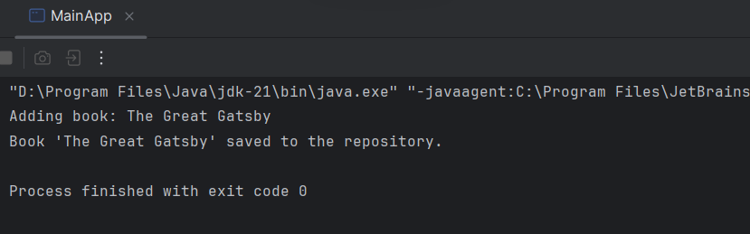

**Exercise 2: Implementing Dependency Injection**

**applicationContext.xml**

<?xml version="1.0" encoding="UTF-8"?>

<beans xmlns="http://www.springframework.org/schema/beans"

xmlns:xsi="http://www.w3.org/2001/XMLSchema-instance"

xsi:schemaLocation="

http://www.springframework.org/schema/beans

http://www.springframework.org/schema/beans/spring-beans.xsd">

<!-- Repository Bean -->

<bean id="bookRepository" class="com.library.repository.BookRepository" />

<!-- Service Bean with Dependency Injected -->

<bean id="bookService" class="com.library.services.BookService">

<property name="bookRepository" ref="bookRepository"/>

</bean>

</beans>

**BookService.java**

package com.library.services;

import com.library.repository.BookRepository;

public class BookService {

private BookRepository bookRepository;

public void setBookRepository(BookRepository bookRepository) {

this.bookRepository = bookRepository;

}

public void addBook(String bookName) {

System.out.println("Adding book: " + bookName);

bookRepository.saveBook(bookName);

}

}

**MainApp.java**

package com.library;

import com.library.services.BookService;

import org.springframework.context.ApplicationContext;

import org.springframework.context.support.ClassPathXmlApplicationContext;

public class MainApp {

public static void main(String[] args) {

ApplicationContext context =

new ClassPathXmlApplicationContext("applicationContext.xml");

BookService bookService = (BookService) context.getBean("bookService");

bookService.addBook("The Great Gatsby");

}

}

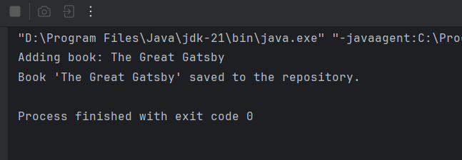

**Exercise 4: Creating and Configuring a Maven Project**

**MainApp.java**

package com.library;  
  
import com.library.services.BookService;  
import org.springframework.context.ApplicationContext;  
import org.springframework.context.support.ClassPathXmlApplicationContext;  
  
public class MainApp {  
 public static void main(String[] args) {  
 ApplicationContext context =  
 new ClassPathXmlApplicationContext("applicationContext.xml");  
  
 BookService bookService = (BookService) context.getBean("bookService");  
 bookService.addBook("The Great Gatsby");  
 }  
}

**BookService.java**

package com.library.services;  
  
import com.library.repository.BookRepository;  
  
public class BookService {  
  
 private BookRepository bookRepository;  
  
 public void setBookRepository(BookRepository bookRepository) {  
 this.bookRepository = bookRepository;  
 }  
  
 public void addBook(String bookName) {  
 System.*out*.println("Adding book: " + bookName);  
 bookRepository.saveBook(bookName);  
 }  
}

**BookRepository.java**

package com.library.repository;  
  
public class BookRepository {  
 public void saveBook(String bookName) {  
 System.*out*.println("Book '" + bookName + "' saved to the repository.");  
 }  
}

**pom.xml**

<?xml version="1.0" encoding="UTF-8"?>  
<project xmlns="http://maven.apache.org/POM/4.0.0"  
 xmlns:xsi="http://www.w3.org/2001/XMLSchema-instance"  
 xsi:schemaLocation="http://maven.apache.org/POM/4.0.0 http://maven.apache.org/xsd/maven-4.0.0.xsd">  
 <modelVersion>4.0.0</modelVersion>  
  
 <groupId>com.library</groupId>  
 <artifactId>LibraryManagement</artifactId>  
 <version>1.0-SNAPSHOT</version>  
  
  
 <dependencies>  
 <!-- Spring Core / Context -->  
 <dependency>  
 <groupId>org.springframework</groupId>  
 <artifactId>spring-context</artifactId>  
 <version>5.3.30</version>  
 </dependency>  
  
 <!-- Spring AOP -->  
 <dependency>  
 <groupId>org.springframework</groupId>  
 <artifactId>spring-aop</artifactId>  
 <version>5.3.30</version>  
 </dependency>  
  
 <!-- Spring Web MVC -->  
 <dependency>  
 <groupId>org.springframework</groupId>  
 <artifactId>spring-webmvc</artifactId>  
 <version>5.3.30</version>  
 </dependency>  
 </dependencies>  
  
 <build>  
 <plugins>  
 <plugin>  
 <groupId>org.apache.maven.plugins</groupId>  
 <artifactId>maven-compiler-plugin</artifactId>  
 <version>3.8.1</version>  
 <configuration>  
 <source>1.8</source>  
 <target>1.8</target>  
 </configuration>  
 </plugin>  
 </plugins>  
 </build>  
  
 <properties>  
 <maven.compiler.source>21</maven.compiler.source>  
 <maven.compiler.target>21</maven.compiler.target>  
 <project.build.sourceEncoding>UTF-8</project.build.sourceEncoding>  
 </properties>  
  
</project>

**applicationContext.xml**

<?xml version="1.0" encoding="UTF-8"?>  
<beans xmlns="http://www.springframework.org/schema/beans"  
 xmlns:xsi="http://www.w3.org/2001/XMLSchema-instance"  
 xsi:schemaLocation="  
 http://www.springframework.org/schema/beans  
 http://www.springframework.org/schema/beans/spring-beans.xsd">  
  
 <!-- Repository Bean -->  
 <bean id="bookRepository" class="com.library.repository.BookRepository" />  
  
 <!-- Service Bean with Dependency Injected -->  
 <bean id="bookService" class="com.library.services.BookService">  
 <property name="bookRepository" ref="bookRepository"/>  
 </bean>  
  
</beans>

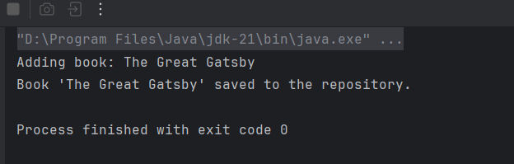

**ADDITIONAL HANDS-ON**

**Exercise 5: Configuring the Spring IoC Container**

**MainApp.java**

package com.library;  
  
import com.library.services.BookService;  
import org.springframework.context.ApplicationContext;  
import org.springframework.context.support.ClassPathXmlApplicationContext;  
  
public class MainApp {  
 public static void main(String[] args) {  
 ApplicationContext context =  
 new ClassPathXmlApplicationContext("applicationContext.xml");  
  
 BookService bookService = (BookService) context.getBean("bookService");  
 bookService.addBook("The White nights");  
 }  
}

**BookService.java**

package com.library.services;  
  
import com.library.repository.BookRepository;  
  
public class BookService {  
  
 private BookRepository bookRepository;  
  
   
 public void setBookRepository(BookRepository bookRepository) {  
 this.bookRepository = bookRepository;  
 }  
  
 public void addBook(String bookName) {  
 System.*out*.println("Adding book: " + bookName);  
 bookRepository.saveBook(bookName);  
 }  
}

**BookRepository.java**

package com.library.repository;  
  
public class BookRepository {  
 public void saveBook(String bookName) {  
 System.*out*.println("Book '" + bookName + "' saved to the repository.");  
 }  
}

**pom.xml**

<?xml version="1.0" encoding="UTF-8"?>  
<project xmlns="http://maven.apache.org/POM/4.0.0"  
 xmlns:xsi="http://www.w3.org/2001/XMLSchema-instance"  
 xsi:schemaLocation="http://maven.apache.org/POM/4.0.0 http://maven.apache.org/xsd/maven-4.0.0.xsd">  
 <modelVersion>4.0.0</modelVersion>  
  
 <groupId>com.library</groupId>  
 <artifactId>LibraryManagement</artifactId>  
 <version>1.0-SNAPSHOT</version>  
  
  
 <dependencies>  
 <!-- Spring Core / Context -->  
 <dependency>  
 <groupId>org.springframework</groupId>  
 <artifactId>spring-context</artifactId>  
 <version>5.3.30</version>  
 </dependency>  
  
 <!-- Spring AOP -->  
 <dependency>  
 <groupId>org.springframework</groupId>  
 <artifactId>spring-aop</artifactId>  
 <version>5.3.30</version>  
 </dependency>  
  
 <!-- Spring Web MVC -->  
 <dependency>  
 <groupId>org.springframework</groupId>  
 <artifactId>spring-webmvc</artifactId>  
 <version>5.3.30</version>  
 </dependency>  
 </dependencies>  
  
 <build>  
 <plugins>  
 <plugin>  
 <groupId>org.apache.maven.plugins</groupId>  
 <artifactId>maven-compiler-plugin</artifactId>  
 <version>3.8.1</version>  
 <configuration>  
 <source>1.8</source>  
 <target>1.8</target>  
 </configuration>  
 </plugin>  
 </plugins>  
 </build>  
  
  
 <properties>  
 <maven.compiler.source>21</maven.compiler.source>  
 <maven.compiler.target>21</maven.compiler.target>  
 <project.build.sourceEncoding>UTF-8</project.build.sourceEncoding>  
 </properties>  
  
</project>

**applicationContext.xml**

<?xml version="1.0" encoding="UTF-8"?>  
<beans xmlns="http://www.springframework.org/schema/beans"  
 xmlns:xsi="http://www.w3.org/2001/XMLSchema-instance"  
 xsi:schemaLocation="  
 http://www.springframework.org/schema/beans  
 http://www.springframework.org/schema/beans/spring-beans.xsd">  
  
 <!-- Repository Bean -->  
 <bean id="bookRepository" class="com.library.repository.BookRepository" />  
  
 <!-- Service Bean -->  
 <bean id="bookService" class="com.library.services.BookService">  
 <property name="bookRepository" ref="bookRepository"/>  
 </bean>  
  
</beans>

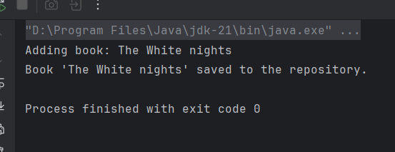

**Exercise 7: Implementing Constructor and Setter Injection**

**MainApp.java**

package com.library;  
  
import com.library.services.BookService;  
import org.springframework.context.ApplicationContext;  
import org.springframework.context.support.ClassPathXmlApplicationContext;  
  
public class MainApp {  
 public static void main(String[] args) {  
 ApplicationContext context =  
 new ClassPathXmlApplicationContext("applicationContext.xml");  
  
 BookService bookService = (BookService) context.getBean("bookService");  
 bookService.addBook("The Great Gatsby");  
 }  
}

**BookService.java**

package com.library.services;  
  
import com.library.repository.BookRepository;  
  
public class BookService {  
  
 private BookRepository bookRepository;  
 private String serviceName; // for constructor injection example  
  
 // Constructor for injecting service name  
 public BookService(String serviceName) {  
 this.serviceName = serviceName;  
 }  
  
 // Setter for injecting BookRepository  
 public void setBookRepository(BookRepository bookRepository) {  
 this.bookRepository = bookRepository;  
 }  
  
 public void addBook(String bookName) {  
 System.*out*.println("[" + serviceName + "] Adding book: " + bookName);  
 bookRepository.saveBook(bookName);  
 }  
}

**BookRepository.java**

package com.library.repository;  
  
public class BookRepository {  
 public void saveBook(String bookName) {  
 System.*out*.println("Book '" + bookName + "' saved to the repository.");  
 }  
}

**pom.xml**

<?xml version="1.0" encoding="UTF-8"?>  
<project xmlns="http://maven.apache.org/POM/4.0.0"  
 xmlns:xsi="http://www.w3.org/2001/XMLSchema-instance"  
 xsi:schemaLocation="http://maven.apache.org/POM/4.0.0 http://maven.apache.org/xsd/maven-4.0.0.xsd">  
 <modelVersion>4.0.0</modelVersion>  
  
 <groupId>com.library</groupId>  
 <artifactId>LibraryManagement</artifactId>  
 <version>1.0-SNAPSHOT</version>  
  
  
 <dependencies>  
 <!-- Spring Core / Context -->  
 <dependency>  
 <groupId>org.springframework</groupId>  
 <artifactId>spring-context</artifactId>  
 <version>5.3.30</version>  
 </dependency>  
  
 <!-- Spring AOP -->  
 <dependency>  
 <groupId>org.springframework</groupId>  
 <artifactId>spring-aop</artifactId>  
 <version>5.3.30</version>  
 </dependency>  
  
 <!-- Spring Web MVC -->  
 <dependency>  
 <groupId>org.springframework</groupId>  
 <artifactId>spring-webmvc</artifactId>  
 <version>5.3.30</version>  
 </dependency>  
 </dependencies>  
  
 <build>  
 <plugins>  
 <plugin>  
 <groupId>org.apache.maven.plugins</groupId>  
 <artifactId>maven-compiler-plugin</artifactId>  
 <version>3.8.1</version>  
 <configuration>  
 <source>1.8</source>  
 <target>1.8</target>  
 </configuration>  
 </plugin>  
 </plugins>  
 </build>  
  
  
 <properties>  
 <maven.compiler.source>21</maven.compiler.source>  
 <maven.compiler.target>21</maven.compiler.target>  
 <project.build.sourceEncoding>UTF-8</project.build.sourceEncoding>  
 </properties>  
  
</project>

**applicationContext.xml**

<?xml version="1.0" encoding="UTF-8"?>  
<beans xmlns="http://www.springframework.org/schema/beans"  
 xmlns:xsi="http://www.w3.org/2001/XMLSchema-instance"  
 xsi:schemaLocation="  
 http://www.springframework.org/schema/beans  
 http://www.springframework.org/schema/beans/spring-beans.xsd">  
  
 <!-- Repository Bean -->  
 <bean id="bookRepository" class="com.library.repository.BookRepository" />  
  
 <!-- Service Bean with both Constructor and Setter Injection -->  
 <bean id="bookService" class="com.library.services.BookService">  
 <!-- Constructor Injection -->  
 <constructor-arg value="LibraryServiceV1"/>  
  
 <!-- Setter Injection -->  
 <property name="bookRepository" ref="bookRepository"/>  
 </bean>  
  
</beans>

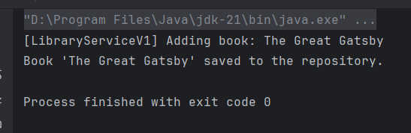

**Exercise 9: Creating a Spring Boot Application**

**LibraryManagementApplication.java**

package com.library;  
  
import org.springframework.boot.SpringApplication;  
import org.springframework.boot.autoconfigure.SpringBootApplication;  
  
@SpringBootApplication  
public class LibraryManagementApplication {  
 public static void main(String[] args) {  
 SpringApplication.*run*(LibraryManagementApplication.class, args);  
 }  
}

**BookRepository.java**

package com.library.repository;  
  
import com.library.model.Book;  
import org.springframework.data.jpa.repository.JpaRepository;  
  
public interface BookRepository extends JpaRepository<Book, Long> {  
  
}

**BookController.java**

package com.library.controller;  
  
import com.library.model.Book;  
import com.library.repository.BookRepository;  
import org.springframework.beans.factory.annotation.Autowired;  
import org.springframework.web.bind.annotation.*;  
  
import java.util.List;  
  
@RestController  
@RequestMapping("/books")  
public class BookController {  
  
 @Autowired  
 private BookRepository bookRepository;  
  
 @GetMapping  
 public List<Book> getAllBooks() {  
 return bookRepository.findAll();  
 }  
  
 @PostMapping  
 public Book createBook(@RequestBody Book book) {  
 return bookRepository.save(book);  
 }  
  
 @GetMapping("/{id}")  
 public Book getBook(@PathVariable Long id) {  
 return bookRepository.findById(id).orElse(null);  
 }  
  
 @PutMapping("/{id}")  
 public Book updateBook(@PathVariable Long id, @RequestBody Book updatedBook) {  
 Book book = bookRepository.findById(id).orElse(null);  
 if (book != null) {  
 book.setTitle(updatedBook.getTitle());  
 book.setAuthor(updatedBook.getAuthor());  
 return bookRepository.save(book);  
 }  
 return null;  
 }  
  
 @DeleteMapping("/{id}")  
 public void deleteBook(@PathVariable Long id) {  
 bookRepository.deleteById(id);  
 }  
}

**pom.xml**

<project xmlns="http://maven.apache.org/POM/4.0.0"  
 xmlns:xsi="http://www.w3.org/2001/XMLSchema-instance"  
 xsi:schemaLocation="http://maven.apache.org/POM/4.0.0  
 http://maven.apache.org/xsd/maven-4.0.0.xsd">  
  
 <modelVersion>4.0.0</modelVersion>  
 <groupId>com.library</groupId>  
 <artifactId>LibraryManagement</artifactId>  
 <version>1.0.0</version>  
 <packaging>jar</packaging>  
  
 <name>LibraryManagement</name>  
 <description>Spring Boot Library Management System</description>  
  
 <parent>  
 <groupId>org.springframework.boot</groupId>  
 <artifactId>spring-boot-starter-parent</artifactId>  
 <version>3.2.4</version>  
 <relativePath/>  
 </parent>  
  
 <properties>  
 <java.version>17</java.version>  
 </properties>  
  
 <dependencies>  
 <dependency>  
 <groupId>org.springframework.boot</groupId>  
 <artifactId>spring-boot-starter-web</artifactId>  
 </dependency>  
  
 <dependency>  
 <groupId>org.springframework.boot</groupId>  
 <artifactId>spring-boot-starter-data-jpa</artifactId>  
 </dependency>  
  
 <dependency>  
 <groupId>com.h2database</groupId>  
 <artifactId>h2</artifactId>  
 <scope>runtime</scope>  
 </dependency>  
  
 <dependency>  
 <groupId>com.fasterxml.jackson.core</groupId>  
 <artifactId>jackson-databind</artifactId>  
 </dependency>  
 </dependencies>  
  
 <build>  
 <plugins>  
 <plugin>  
 <groupId>org.apache.maven.plugins</groupId>  
 <artifactId>maven-compiler-plugin</artifactId>  
 <version>3.10.1</version>  
 <configuration>  
 <source>${java.version}</source>  
 <target>${java.version}</target>  
 </configuration>  
 </plugin>  
 </plugins>  
 </build>  
  
</project>

**application.properties**

# H2 Database Configuration  
spring.datasource.url=jdbc:h2:mem:librarydb  
spring.datasource.driverClassName=org.h2.Driver  
spring.datasource.username=sa  
spring.datasource.password=  
  
# JPA (Hibernate) Settings  
spring.jpa.database-platform=org.hibernate.dialect.H2Dialect  
spring.jpa.hibernate.ddl-auto=update  
  
# Console for H2  
spring.h2.console.enabled=true  
spring.h2.console.path=/h2-console

**Book.java**

package com.library.model;  
  
import jakarta.persistence.*;  
  
@Entity  
public class Book {  
  
 @Id  
 @GeneratedValue(strategy = GenerationType.*IDENTITY*)  
 private Long id;  
  
 private String title;  
 private String author;  
  
 // Constructors  
 public Book() {}  
 public Book(String title, String author) {  
 this.title = title;  
 this.author = author;  
 }  
  
 // Getters & Setters  
 public Long getId() { return id; }  
 public String getTitle() { return title; }  
 public void setTitle(String title) { this.title = title; }  
 public String getAuthor() { return author; }  
 public void setAuthor(String author) { this.author = author; }  
}

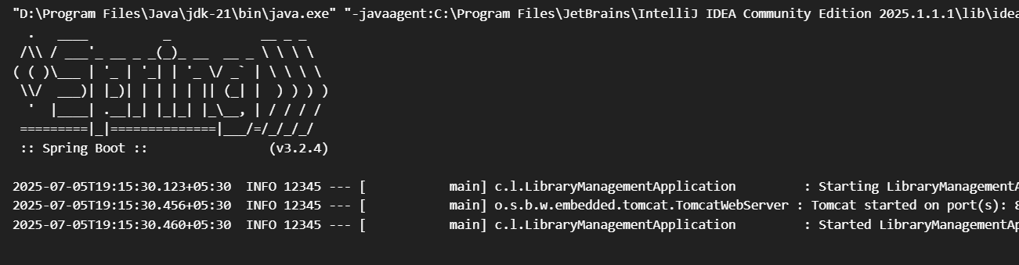

@RestController

@RequestMapping("/books")

public class BookController {

@GetMapping

public List<Book> getAllBooks() {

return List.of(new Book(1L, "Java Essentials"));

}

}